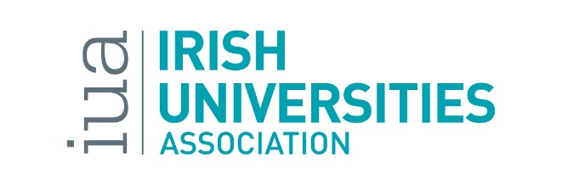

Student Associate Internship for Enhancing Digital Capacity in Teaching and Learning in Irish Universities

The Irish Universities Association is currently looking to recruit a Student Associate Intern for the project: Enhancing Digital Capacity in Teaching and Learning in Irish Universities. This is a fixed term internship for the period 1 November 2019 – 31 March 2020.
This is a part-time position, 15 hours per week, at a rate of €13.69 per hour. The appointee will be required in the IUA offices, Merrion Square, Dublin 2 for 1 full working day per week. The remainder of hours can be done in your own time. The IUA will aim to be as flexible as possible in relation to working arrangements.
Enhancing Digital Capacity in Teaching and Learning in Irish Universities is a new project, co-ordinated by the Irish Universities Association and funded through the Higher Education Authority Innovation and Transformation Programme, aimed at enhancing the digital attributes and educational experiences of Irish university students. This will be done by enabling the mainstreamed and integrated use of digital technologies across the teaching and learning process.
To achieve these objectives, the project will develop, pilot, review and roll out an ambitious professional development programme to enhance the digital confidence, skills and competences of those who teach in Irish universities. Working closely with senior academic, IT and professional development leaders across the university sector, the goal is to empower those who teach to integrate digital technologies into their own pedagogies, teaching & learning, and assessment practices in effective and meaningful ways.
This is an excellent opportunity for the right candidate to expand their understanding of digital capacity in teaching and learning in Irish universities and the direct impact its future development will have on students and the student experience. Working alongside the rest of the project team, the successful candidate will play a key role in bringing the student voice to the project activities and communications.

The Role
Reporting to the IUA project manager, the student associate intern will be a full member of the project team.
Specifically, they will be expected to:
- act as a full member of the project team, including attending and contributing to project team meetings;
- liaise with project team members and student union representatives on each university campus;
- liaise with USI and National Forum student associate interns (e.g. in relation to the INDEx surveys);
- run student-led social media for the project, in collaboration with students involved in the pilot groups, student unions and campus student digital champions;
- contribute to project communications, including podcast/video recording, presenting at events or panel discussions, provide comments for the media;
- support the activities of the project manager.
A Student Associate Internship Learning Contract will be drawn up between the student associate intern and the IUA to ensure clear expectations are set and that the partnership is beneficial to both parties.

Key Attributes
The candidate should satisfy a number of ESSENTIAL criteria:
- Be enrolled as a current student in one of the Irish universities or a recent graduate (within the last 12 months) of an Irish university
- Be able to commit to working at least one day per week from the IUA offices
- Have a strong interest in the use of digital tools and technologies in teaching and learning in Irish universities

The candidate should also aim to satisfy the following DESIRABLE criteria:
- Experience of research and research methods
- Demonstrable leadership skills
- Good organisational skills
- Strong written and oral communication skills and the ability to communicate effectively with both students and management in higher education

Contract details
This is a part-time position, 15 hours per week, at a rate of €13.69 per hour. The appointee will be required in the IUA offices, Merrion Square, Dublin 2 for 1 full working day per week. The remainder of hours can be done in your own time. The IUA will aim to be as flexible as possible in relation to working arrangements.
The position of student associate intern is a fixed term internship for the period 1 November 2019 – 31 March 2020, subject to meeting on-going performance requirements. The role may require some travel within Ireland. All reasonable and pre-approved travel costs associated with the internship will be covered by the IUA.

Application details
Please forward
- An up to date Curriculum Vitae
- A personal statement (not more than 350 words) clearly outlining what you feel you can contribute to the Enhancing Digital Capacity in Teaching and Learning project and how this internship would support your own personal development
- A brief cover letter
by email to sharon.flynn@iua.ie by 5pm on Tuesday 15 October 2019

