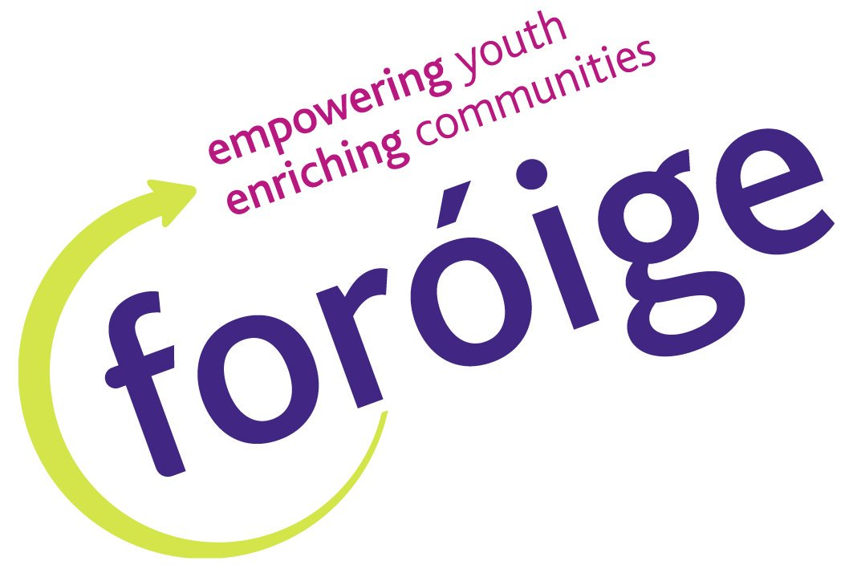

CONNECTIONS YOUTH CLUB – LEADERS WANTED
We are a Youth Club that meets every Tuesday Night 8pm – 9.45pm from September to June in Whitehall Scouts Den, 134a Larkhill Road, Whitehall.

We cater our club to teens that may be lacking in social skills, have low confidence and are looking to get out of the house and have some fun. Our young people range from 12/13 years (first year in secondary school) to 18 years old.
We welcome young persons with ASD, learning difficulties or limited social skills to come and join us and our current members, some of which have been with us for 6 years!

Our mission is to provide a fun and caring environment to enable members to develop their own abilities and skills, gain some confidence and make connections!

We are currently looking for enthusiastic, confident and energetic leaders willing to be engaged and actively involved and who can commit to every Tuesday evening from 7.45 – 9.45pm. Garda Vetting and Child Protection will be required.

For more details contact

Janice at 086 0659242 or Simon at 085 7863478

And check out our Facebook Page Connections Foroige

